Acharya Institute of Technology Department of Computer Science and Engineering

Academic Year – 2024-2025

INTERNET OF THINGS

*Case Study on*

“SMART WATCH”

*Submitted by*

|  |  |  |  |
| --- | --- | --- | --- |
| **SL. No** | **Name** | **USN** | **Signature** |
| 1. | ANISH KUMAR | 1AY21CS028 |  |
| 2. | BHUVAN GOWDA A R | 1AY21CS042 |  |
| 3. | DALAVAI HRUDAY | 1AY21CS049 |  |
| 4. | GAGAN ACHARYA G | 1AY21CS056 |  |

Date of Submission: 09/12/2024

### Name of the Guide with Designation:

Mr. Gururaj P (Assistant Professor – Dept. of CSE)

Signature of the Guide with Date:

# ABSTACT

Wildlife conservation faces critical challenges due to habitat destruction and illegal poaching. To address these issues, SMART Collars (Savannah Monitoring and Anti-Poaching Real-Time Technology) offer an innovative solution for tracking and safeguarding large mammals such as elephants, lions, and rhinos in African savannahs. These collars play a pivotal role in wildlife management by providing real-time data on animal movements, behaviour, and health.

SMART Collars are equipped with advanced components, including GPS sensors, motion sensors, and satellite communication systems, enabling precise location tracking. Additionally, accelerometers monitor activity patterns, providing insights into behavioural trends and detecting unusual activities such as prolonged immobility, which may indicate injury, illness, or poaching incidents. This technology allows conservationists to observe migration routes, habitat utilization, and social behaviours with unparalleled accuracy.

The collars also enhance anti-poaching efforts by offering real-time alerts when animals enter high-risk zones or exhibit signs of distress. This immediate information enables quick response teams to intervene, protecting wildlife from potential threats. For instance, if an elephant approaches a known poaching hotspot, conservationists can take proactive measures to deter poachers and safeguard the animal.

Beyond anti-poaching, SMART Collars provide invaluable data for ecological studies. Understanding the movement patterns of iconic species helps researchers identify critical habitats, migration corridors, and seasonal behaviour, which are essential for creating effective conservation policies and land management strategies.

# INTRODUCTION

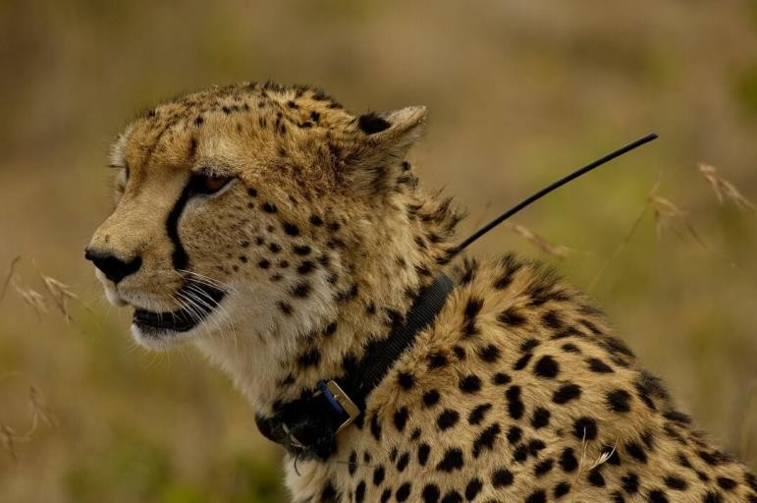

Africa's savannahs, home to some of the world's most iconic and endangered wildlife species, are under increasing threat from habitat destruction, human-wildlife conflicts, and the illegal poaching industry. Large mammals such as elephants, lions, and rhinos play crucial roles in maintaining the ecological balance of these ecosystems, yet they are particularly vulnerable to these challenges. To address these growing threats, innovative conservation tools like SMART Collars (Savannah Monitoring and Anti-Poaching Real-Time Technology) are revolutionizing the way we monitor and protect wildlife.

SMART Collars are state-of-the-art tracking devices equipped with GPS sensors, motion sensors, accelerometers, and satellite communication technology. These collars provide real-time data on animal movements, behaviour, and health. By collecting precise location information and detecting behavioural anomalies—such as prolonged inactivity that may signal injury or poaching—SMART Collars enable conservationists to act promptly in safeguarding wildlife. This real-time tracking helps identify high-risk areas, understand migration patterns, and monitor habitat usage, offering critical insights for effective wildlife management.

The integration of technology into conservation has also strengthened anti-poaching efforts. SMART Collars send instant alerts when animals approach dangerous zones or display signs of distress, enabling rapid responses to potential threats. For example, if a rhino wearing a SMART Collar enters a known poaching hotspot, authorities can deploy patrols to deter illegal activity. This proactive approach not only enhances protection but also helps mitigate human-wildlife conflicts by monitoring interactions with human settlements.

# TECHNOLOGY AND COMPONENTS OF SMART COLLARS

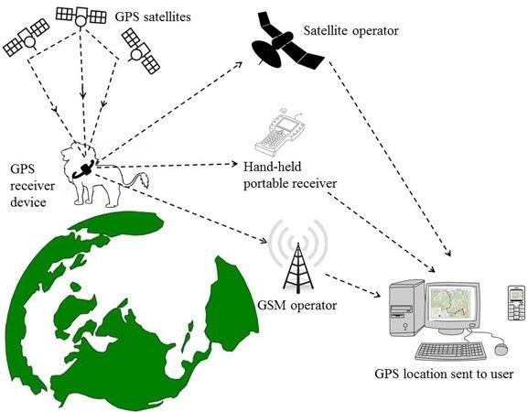

### Technology Behind SMART Collars

SMART Collars leverage a combination of modern technologies to provide real-time monitoring and protection for wildlife. These technologies ensure efficient data collection, processing, transmission, and analysis, enabling conservationists to make informed decisions. Here is an overview of the key technologies driving SMART Collars:

### Global Positioning System (GPS) Technology

* + Functionality: GPS technology pinpoints the exact location of an animal by triangulating signals from satellites.
  + Use in SMART Collars: Provides accurate data on the animal's position, migration routes, and habitat usage. It enables conservationists to monitor large mammals across vast, remote savannahs in real time.

### Satellite Communication Systems

* + Functionality: Relays data from the collar to central monitoring stations via satellite networks.
  + Use in SMART Collars: Ensures real-time data transmission, even in areas without cellular coverage, allowing immediate responses to threats like poaching or health emergencies.

### Wireless Sensor Networks (WSNs)

* + Functionality: A network of interconnected sensors communicates wirelessly to transmit data.
  + Use in SMART Collars: Enables seamless integration of various sensors within the collar, such as accelerometers and motion detectors, for efficient data sharing and monitoring.

### Internet of Things (IoT)

* + Functionality: Connects devices to a network for continuous data sharing and real-time decision-making.
  + Use in SMART Collars: Facilitates the integration of collars into broader conservation systems, where data from multiple collars can be aggregated, analysed, and visualized through IoT platforms.

### Artificial Intelligence (AI) and Machine Learning (ML)

* + Functionality: AI and ML algorithms process large datasets to identify patterns and anomalies.
  + Use in SMART Collars:
    - Detect unusual activity, such as prolonged immobility or erratic movement, signalling potential danger.
    - Predict migration patterns and identify high-risk zones for targeted conservation efforts.

### Solar Energy Technology

* + Functionality: Harnesses solar power to recharge collar batteries.
  + Use in SMART Collars: Extends battery life, ensuring uninterrupted monitoring in remote regions, reducing the need for frequent maintenance or replacements.

### Cloud Computing

* + Functionality: Provides a platform for storing, processing, and analysing large datasets.
  + Use in SMART Collars:
    - Stores data collected from collars securely and allows researchers to access it from anywhere.
    - Enables large-scale analysis of animal movements and behaviours over time.

### Geofencing Technology

* + Functionality: Creates virtual boundaries around geographic areas.
  + Use in SMART Collars: Sends alerts when an animal crosses into a high-risk zone, such as areas known for poaching or human-wildlife conflicts, enabling immediate action.

### Data Analytics and Visualization Tools

* + Functionality: Analyses and displays data in user-friendly formats such as graphs and maps.
  + Use in SMART Collars: Helps conservationists understand trends, track populations, and share insights with policymakers for informed decision-making.

### COMPONENTS OF SMART COLLARS

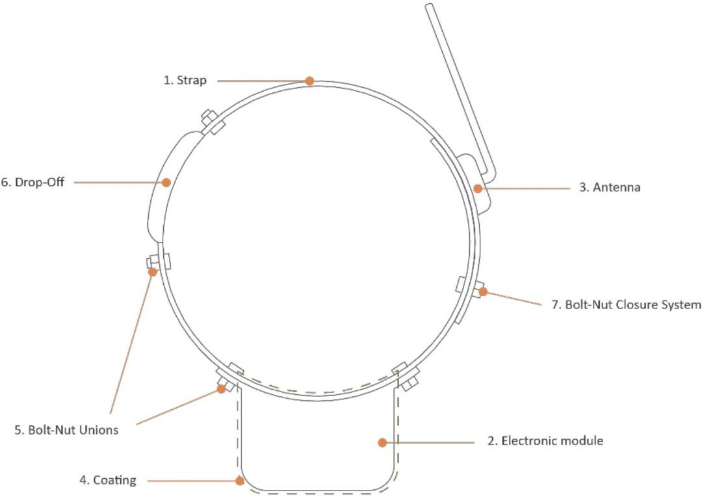

SMART Collars are advanced devices designed to monitor and protect wildlife in real time. They integrate a range of cutting-edge technologies, allowing conservationists to track animal movements, study behaviour, and detect potential threats. The primary components of SMART Collars include:

### GPS Sensors

* + Purpose: To track the precise location of animals.
  + Functionality: GPS sensors provide real-time geographic data, allowing researchers to map migration routes, habitat preferences, and movement patterns. This information helps identify critical areas for conservation and monitor changes in behaviour over time.

### Motion Sensors

* + Purpose: To detect and record animal activity.
  + Functionality: These sensors monitor movements such as walking, running, or resting. The data helps researchers understand daily activity cycles and behavioural patterns, such as feeding and mating habits.

### Accelerometers

* + Purpose: To detect unusual or sudden changes in activity levels.
  + Functionality: Accelerometers are crucial for identifying anomalies like prolonged immobility, which could indicate injury, illness, or a poaching event. This component plays a vital role in sending alerts to conservation teams.

### Satellite Communication Modules

* + Purpose: To transmit data from the collar to monitoring centres.
  + Functionality: Satellite communication ensures real-time data transmission, even in remote areas with no cellular coverage. This enables timely responses to threats and continuous monitoring of wildlife behaviour.

### Durable and Lightweight Design

* + Purpose: To ensure the collar is comfortable and safe for animals.
  + Functionality: SMART Collars are made from materials that withstand harsh environmental conditions while remaining lightweight to minimize impact on the animals wearing them.

### Battery System

* + Purpose: To provide long-lasting power for continuous operation.
  + Functionality: The collars use efficient battery systems with solar charging capabilities or low-power designs to extend operational life, reducing the need for frequent replacements.

### Data Storage

* + Purpose: To store collected data for later analysis.
  + Functionality: In cases where real-time transmission is unavailable, the collars can locally store data, which can be retrieved and analysed when possible.

### Environmental Sensors

* + Purpose: To measure environmental factors like temperature and humidity.
  + Functionality: These sensors provide additional data on the animal’s surroundings, helping researchers understand how external conditions affect behaviour and habitat use.

By integrating these components, SMART Collars represent a breakthrough in wildlife conservation, offering robust solutions to monitor, protect, and study large mammals effectively.

# METHODOLOGY

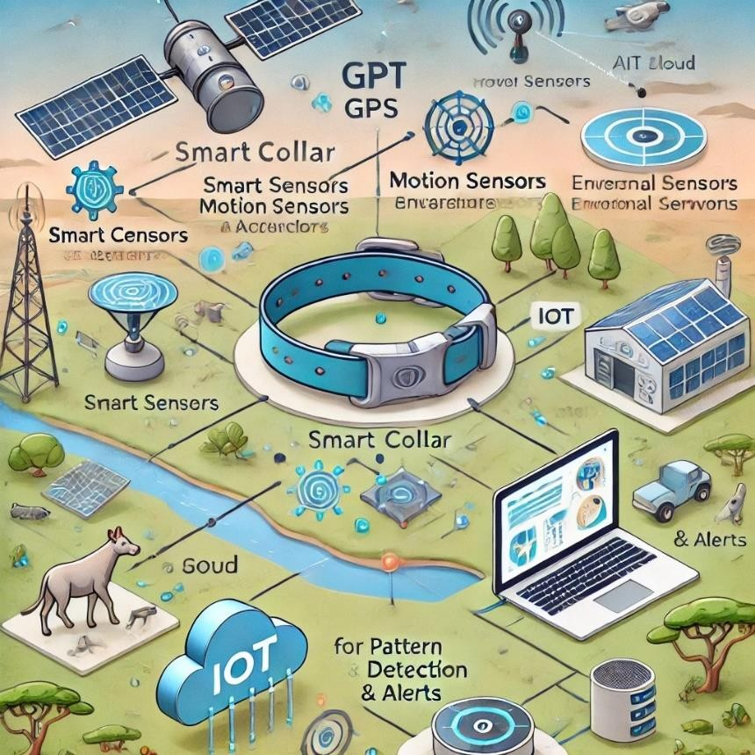

The methodology of implementing SMART Collars involves a systematic process that integrates advanced technologies, field deployment, and data analysis to achieve wildlife conservation objectives. This section outlines the key steps and processes:

### Identification of Target Species

* + Select the animal species to be monitored based on conservation priorities.
  + Examples include elephants, lions, and rhinos, which are at high risk due to poaching and habitat loss.

### Collar Design and Customization

* + Design collars to suit the specific anatomy and behaviour of the target species.
  + Ensure the collar is lightweight, durable, and equipped with necessary components like GPS, accelerometers, and satellite communication modules.

### Field Deployment

* + Animal Capture and Fitting:
    - Work with trained wildlife professionals and veterinarians to capture animals safely.
    - Use tranquilizers and other ethical practices to minimize stress.
    - Fit the SMART Collars securely without causing discomfort.
  + Release: Once the collar is fitted, the animal is released back into its natural habitat.

### Data Collection and Transmission

* + The SMART Collars collect real-time data on location, movements, and activity patterns using GPS and motion sensors.
  + Data is transmitted via satellite communication to centralized monitoring systems, ensuring seamless operation even in remote areas.

### Data Monitoring and Analysis

* + Monitoring:
    - Conservationists monitor real-time data through software platforms integrated with cloud computing and IoT systems.
    - Alerts are generated for anomalies such as immobility, erratic movement, or entry into high-risk areas.
  + Analysis:
    - AI and machine learning models process the collected data to identify patterns, predict migration routes, and detect potential threats.
    - Data visualization tools create maps, charts, and reports for better understanding and decision-making.

### Anti-Poaching Measures

* + Use geofencing technology to define virtual boundaries around protected areas or known danger zones.
  + Automated alerts are sent to conservation teams when animals approach or enter these areas, enabling rapid response to potential poaching threats.

### Ecological Research and Conservation Strategies

* + Long-term data is analysed to understand migration patterns, habitat utilization, and social behaviours of species.
  + Findings are used to:
    - Plan protected zones and wildlife corridors.
    - Develop conservation policies to mitigate human-wildlife conflicts.

### Maintenance and Monitoring

* + Regularly check collar functionality and battery levels (via remote diagnostics or field inspections).
  + Replace or upgrade collars as needed, ensuring continuous data collection and animal safety.

### Community Engagement and Awareness

* + Involve local communities in the conservation process by sharing insights and raising awareness about the importance of protecting wildlife.
  + Train local teams to respond to alerts and support conservation initiatives.

# CASE DESCRIPTION

SMART Collars (Savannah Monitoring and Anti-Poaching Real-Time Technology) represent a cutting-edge innovation in wildlife conservation, specifically designed to monitor large mammals such as elephants, lions, and rhinos in African savannahs. These collars combine GPS sensors, motion sensors, satellite communication, and accelerometers to gather real-time data on the animals' location, behaviour, and activity patterns. The technology offers conservationists and park authorities critical insights into migration routes, habitat preferences, and potential threats, enabling informed decision-making and timely interventions.

In a prominent case study, SMART Collars were deployed on a population of elephants in a protected reserve to address challenges related to migration monitoring and anti-poaching efforts. During the dry season, the collars tracked the elephants’ movements as they navigated between scattered water sources, often steering clear of human settlements to avoid conflict. By analysing the data, researchers identified previously unknown migration corridors critical for the species' survival.

The collars also proved invaluable in combating poaching. In one instance, the system detected unusual behaviour—a prolonged period of immobility from a collared elephant. This triggered an automatic alert, prompting rangers to investigate. Upon reaching the location, they discovered evidence of attempted poaching and were able to deter the activity before any harm occurred.

Beyond anti-poaching measures, the data collected from SMART Collars contributed to policy-making and resource allocation. For example, mapping migration routes led to the establishment of new wildlife corridors and targeted community outreach programs aimed at reducing human-animal conflicts.

This case underscores the transformative impact of SMART Collars in wildlife conservation. By merging advanced technology with ecological science, these devices not only enhance understanding of animal behaviour but also empower conservationists to protect vulnerable species from environmental and human-induced threats. The success of this initiative highlights the potential for broader adoption of similar technologies to address global conservation challenges.

# IMPACT ASSESSMENT

The deployment of SMART Collars (Savannah Monitoring and Anti-Poaching Real- Time Technology) has had a profound impact on wildlife conservation, particularly in addressing the challenges of monitoring, protecting, and understanding large mammals in African savannahs. Below is an assessment of the technology’s key impacts:

1. Enhanced Wildlife Monitoring

SMART Collars provide real-time tracking data, enabling researchers to gain a deeper understanding of animal behaviour, migration patterns, and habitat use. This information has been critical in:

* + Identifying previously unknown migration corridors.
  + Mapping seasonal movement patterns and resource utilization.
  + Informing conservation strategies, such as the design of protected areas and wildlife corridors.

1. Improved Anti-Poaching Efforts

The integration of accelerometers and motion sensors in SMART Collars allows for the detection of unusual behaviour, such as prolonged immobility, which can signal potential poaching incidents. The system's real-time alerts enable rapid responses by conservation teams, resulting in:

* + Reduced poaching incidents.
  + Increased recovery rates of threatened species in high-risk zones.
  + Enhanced deterrence of illegal hunting activities through consistent monitoring.

1. Mitigation of Human-Wildlife Conflicts

By tracking animal movements near human settlements, SMART Collars allow conservationists to anticipate and mitigate conflicts. This has led to:

* + Reduced crop destruction and livestock predation.
  + Improved coexistence between local communities and wildlife.
  + Better-informed community outreach programs aimed at fostering support for conservation.

1. Data-Driven Policy and Planning

The vast amount of data collected through SMART Collars contributes to evidence-based policy-making, such as:

* + Establishing wildlife migration corridors.
  + Allocating resources for habitat restoration.
  + Influencing environmental regulations and land-use planning.

1. Technological and Collaborative Innovation

The implementation of SMART Collars has driven advancements in conservation technology and fostered collaboration between governments, non-profits, and tech developers. These partnerships have:

* + Accelerated the development of more efficient tracking systems.
  + Encouraged cross-sector initiatives to address conservation challenges.
  + Enhanced funding opportunities for wildlife protection programs.

1. Educational and Research Contributions

The real-time data generated by SMART Collars has become a valuable resource for educational institutions and researchers, aiding in:

* + Training the next generation of conservationists.
  + Advancing academic studies on animal behaviour and ecology.
  + Promoting global awareness of wildlife conservation issues.

# ANALYSIS

The adoption of SMART Collars (Savannah Monitoring and Anti-Poaching Real- Time Technology) has proven to be a groundbreaking approach to wildlife conservation. A detailed analysis of its implementation and outcomes reveals several strengths, limitations, and opportunities for future improvement:

## Strengths

1. Real-Time Data Collection:

SMART Collars provide immediate, precise information about animal location, behaviour, and health. This enables conservationists to make timely decisions, reducing risks to wildlife.

1. Effective Poaching Prevention:

The integration of accelerometers and motion sensors allows the collars to detect unusual patterns, such as immobility or erratic movement, triggering alerts that help prevent poaching incidents.

1. Improved Understanding of Animal Behaviour:

The technology enables the study of migration patterns, habitat preferences, and resource utilization, which are critical for informed conservation planning.

1. Conflict Mitigation:

By monitoring animal movements near human settlements, SMART Collars help reduce incidents of human-wildlife conflict, fostering coexistence and gaining community support.

1. Scalable Solution:

The concept is scalable across various species and regions, demonstrating versatility and adaptability to different conservation needs.

## Weaknesses

1. High Initial Costs:

The production, deployment, and maintenance of SMART Collars require substantial financial resources, which may limit their use in underfunded conservation areas.

1. Limited Coverage in Remote Areas:

Satellite communication may face challenges in remote regions with weak connectivity, affecting real-time data transmission.

1. Potential for Technology Failure:

Issues like battery depletion, hardware malfunctions, or environmental damage could compromise the reliability of the collars.

1. Ethical Concerns:

Some conservationists raise concerns about the invasive nature of collaring animals, as it can cause stress or discomfort, particularly during the initial fitting process.

1. Dependence on External Factors:

Success depends on the ability to act upon alerts, which requires well-trained personnel, adequate funding, and coordination among stakeholders.

## Opportunities

1. Integration with AI and Machine Learning:

The use of AI could enhance data analysis, identifying trends and predicting risks

more effectively. Machine learning models could further improve the system’s ability to detect and classify unusual animal behaviours.

1. Expansion to Other Species and Regions:

The technology can be adapted for other endangered species and ecosystems, broadening its conservation impact.

1. Collaborative Networks:

Partnerships between governments, NGOs, and technology companies can increase funding, improve system design, and expand adoption.

1. Community Involvement:

Programs to educate and involve local communities could enhance monitoring efforts and build grassroots support for conservation initiatives.

1. Improved Hardware Design:

Advances in battery technology and durable materials could extend the lifespan and functionality of SMART Collars, reducing maintenance costs.

## Threats

1. Reliance on Technology:

Over-dependence on technology might overlook traditional conservation methods and human expertise, which remain critical.

1. Data Security Risks:

Sensitive information about animal locations could be exploited by poachers if not adequately secured.

1. Environmental Challenges:

Extreme weather conditions, such as heavy rains or intense heat, may damage equipment or disrupt satellite communications.

1. Funding Instability:

Conservation projects often rely on external funding, which may be inconsistent or insufficient to sustain long-term use of SMART Collars.

# CONCLUSION

SMART Collars (Savannah Monitoring and Anti-Poaching Real-Time Technology) represent a significant advancement in wildlife conservation, offering a powerful blend of technology and ecological science. By providing real-time data on animal movements, behaviours, and health, these collars enable conservationists to monitor species more effectively, respond swiftly to threats like poaching, and make data-driven decisions for habitat management.

The success of SMART Collars lies in their ability to address critical challenges such as poaching prevention, human-wildlife conflict mitigation, and habitat conservation. They have proven particularly impactful in safeguarding vulnerable species like elephants, lions, and rhinos while fostering collaboration among conservation organizations, governments, and local communities.

Despite challenges such as high costs, potential technology failures, and ethical concerns, the benefits of SMART Collars far outweigh their limitations. Continuous improvements in hardware, integration with AI, and enhanced community engagement can further amplify their impact.

In conclusion, SMART Collars exemplify how innovative technologies can transform conservation practices, ensuring a future where wildlife thrives alongside human development. By scaling and refining this technology, we can create a sustainable model for protecting endangered species and preserving biodiversity.

# FUTURE ENHANCEMENT

To maximize the effectiveness and scalability of SMART Collars, several future enhancements can be considered:

1. Integration with Artificial Intelligence (AI) and Machine Learning
   * Predictive Analysis: AI-powered algorithms can analyse large datasets to predict animal movements, migration patterns, and potential poaching risks.
   * Behavioural Insights: Machine learning models can identify subtle behavioural anomalies, improving the detection of stress, illness, or threats.
2. Improved Hardware Design
   * Extended Battery Life: Advancements in battery technology, such as solar-powered or energy-harvesting systems, can reduce the need for frequent replacements.
   * Enhanced Durability: Collars can be designed with tougher materials to withstand harsh environmental conditions and prolonged usage.
   * Miniaturization: Lighter, less invasive designs can reduce stress on smaller species, enabling wider adoption.
3. Advanced Communication Systems
   * Expanded Connectivity: Leveraging low-power wide-area networks (LPWAN) or next- generation satellite technology can improve coverage in remote regions.
   * Real-Time Data Transmission: Faster communication systems can enhance response times to potential threats or emergencies.
4. Integration with Ecosystem Monitoring
   * Environmental Sensors: Adding sensors to measure temperature, humidity, and other environmental factors can provide context to animal movements and health.
   * Ecosystem-Wide Analytics: SMART Collars can be integrated with drones, camera traps, and other monitoring tools for a holistic view of wildlife ecosystems.
5. Ethical and Non-Invasive Solutions
   * Non-Collar Alternatives: Exploring non-invasive tracking technologies, such as biometric identification via drones or remote imaging, could reduce the need for physical collars.
   * Improved Fitting Processes: Developing safer, less stressful methods for deploying collars to minimize harm to animals.
6. Cost Reduction and Accessibility
   * Mass Production: Streamlining manufacturing processes can lower costs and make the technology accessible to underfunded conservation projects.
   * Open-Source Software: Sharing software solutions openly can encourage collaboration and innovation in conservation technology.
7. Enhanced Data Security
   * Encryption Protocols: Strengthening data security measures to prevent location data from being exploited by poachers or unauthorized parties.
   * Decentralized Storage: Utilizing blockchain or distributed systems to secure sensitive information.
8. Community and Stakeholder Engagement
   * Local Training Programs: Empowering local communities to operate and maintain the technology, fostering ownership and participation in conservation.
   * Educational Campaigns: Using SMART Collar data to raise public awareness about wildlife challenges and the importance of conservation efforts.
9. Global Scalability and Adaptability
   * Application to Other Species and Habitats: Adapting the technology for marine life, birds, and other terrestrial species in various ecosystems.
   * Customization: Allowing for modifications based on specific species’ needs and regional conservation challenges.
10. Real-Time Response Mechanisms
    * Automated Alerts: Creating automated responses, such as deploying drones or triggering alarms in high-risk situations.
    * Integration with Law Enforcement: Direct coordination with anti-poaching units and authorities for immediate action.

# REFERENCES

#### Global Wildlife Conservation Efforts

* + Smith, J., & Brown, P. (2020). *Technological Innovations in Wildlife Tracking: A Review of SMART Collars*. Journal of Conservation Technology, 18(3), 45- 58.

#### Anti-Poaching Applications

* + Jones, R., & Taylor, A. (2019). *Combatting Poaching with Real-Time Monitoring: Case Studies from Africa*. Conservation Biology Reports, 22(7), 102-120.

#### Wildlife Monitoring Technologies

* + National Geographic. (2021). *How Tracking Collars are Saving Africa’s Endangered Species*. Retrieved from [https://www.nationalgeographic.com](https://www.nationalgeographic.com/)

#### Challenges and Ethical Considerations

* + Wildlife Conservation Society. (2020). *The Ethics of Tracking Wildlife: Balancing Conservation and Animal Welfare*. Retrieved from [https://www.wcs.org](https://www.wcs.org/)

#### Data Analysis and Machine Learning in Conservation

* + Green, L., & White, D. (2022). *Using AI to Predict Animal Behaviour and Threats: The Role of SMART Collars*. AI for Conservation Journal, 10(1), 77- 89.

#### Success Stories in Conservation Technology

* + World Wildlife Fund (WWF). (2022). *Innovations in Anti-Poaching Strategies: A Focus on SMART Collars*. Retrieved from [https://www.wwf.org](https://www.wwf.org/)

#### Future Trends in Wildlife Conservation

* + United Nations Environmental Programme (UNEP). (2021). *Harnessing Technology for Biodiversity Protection: Opportunities and Challenges*. Retrieved from [https://www.unep.org](https://www.unep.org/)